

WASH K10 BEYE

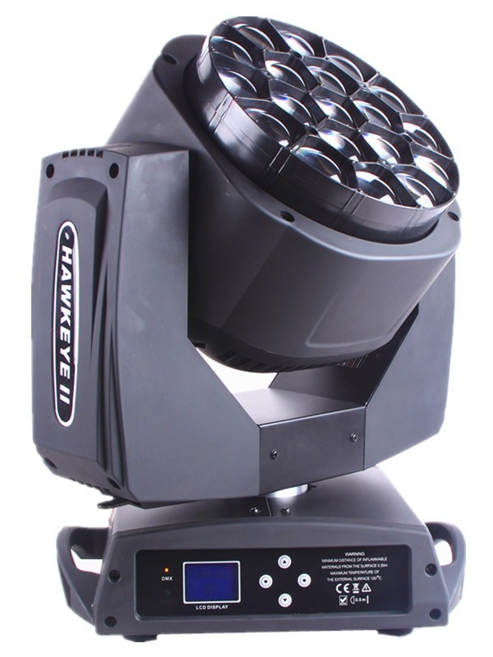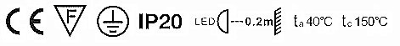

User Manual
KEEP THIS MANUAL FOR FUTURE NEEDS

1. Unpacking
Thank you for choosing our lighting. For your own safety, please read this manual before installing the device. This manual covers the important information on installation and applications. Please install and operate the fixture with following instructions. Meanwhile, please keep this manual well for future needs.

This fixture is made of a new type of high temperature strength of engineering plastics and cast aluminum casing with nice outlook. The fixture is designed and manufactured strictly following CE standards, complying with international standard DMX512 protocol. It’s available independently controlled and linkable with each other for operation. And it is applicable for large-scale live performances, theater, studio,nightclubs and discos.

4-IN -1 LEDs(RGBW) which features high brightness and stability. Please carefully un pack it when you receive the fixture and check whether it is damaged during the transportation. And please check whether the following items are included inside the box.

Moving Head---------One Signal Cable----One

Hanging Bracket-----Two Power Cable----One

Safety Cable---------one User Manual----One

2. Product Introduction
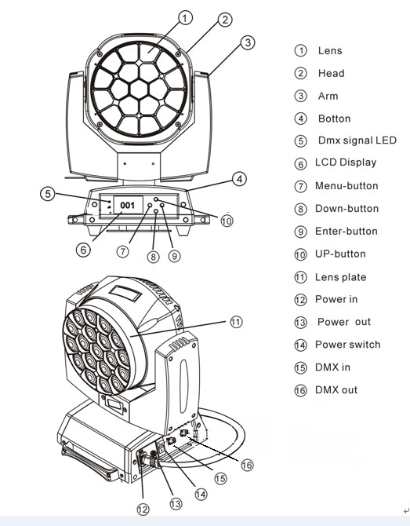

3. Safety Instructions

This device has left the factory in perfect condition. In order to maintain this condition and to ensure a safe operation, it is absolutely necessary for the user to follow the safety instructions and warning notes written in this user manual.

If the device has been exposed to temperature changes due to environmental changes, do not switch it on immediately. The arising condensation could damage the device. Leave the device switched off until it has reached room temperature.
This device falls under protection -class I. Therefore it is essential that the device be earthed.
The electric connection must carry out by qualified person.
The device shall only be used with rate voltage and frequency.
Make sure that the available voltage is not higher than stated at the end of this manual.
Make sure the power cord is never crimped or damaged by sharp edges. If this would be the case, replacement of the cable must be done by an authorized dealer.
Always disconnect from the mains, when the device is not in use or before cleaning it. Only handle the power cord by the plug. Never pull out the plug by tugging the power cord.
During initial start-up some smoke or smell may arise. This is a normal process and does not necessarily mean that the device is defective, it should decrease gradually.
Please don't project the beam onto combustible substances.
Fixtures cannot be installed on combustible substances, keep more than 50cm distance with wall for smooth air flow, so there should be no shelter for fans and ventilation for heat radiation.
If the external flexible cable or cord of this luminaire is damaged, it shall
be exclusively replaced by the manufacturer or his service agent or a similar qualified person in order to avoid a hazard.

4. Operation Instructions
The moving head is for wash effect for on-site decoration purpose.
Don’t turn on the fixture if it’s been through severe temperature difference like after transportation because it might damage the light due to the environment changes. So make sure to operate the fixture until it is in normal temperature .
This light should be keep away from strong shaking during any transportation or movement.
Don’t pull up the light by only the head, or it might cause damages to the mechanical parts.
Don’t expose the fixture in overheat, moisture or environment with too much dust when installing it. And don’t lay any power cables on the floor. Or it might cause electronic shock to the people.
Make sure the installation place is in good safety condition before installing the fixture.
Make sure to put the safety chain and check whether the screws are screwed properly when installing the fixture.
Make sure the lens are in good condition. It’s recommended to replace the units if there are any damages or severe scratch.
Make sure the fixture is operated by qualified personnel who knows the fixture before using.
Keep the original packages if any second shipment is needed.
Don’t try to change the fixtures without any instruction by the manufacturer or the appointed repairing agencies.
It is not in warranty range if there are any malfunctions from not following the user manual to operate or any illegal operation, like shock short circuit, electronic shock, lamp broke, etc.

5. Mounting and Installation
Cautions: For added protection mount the fixtures in areas outside walking paths, seating areas, or in areas were the fixture might be reached by unauthorized personnel.
Before mounting the fixture to any surface, make sure that the installation area can hold a minimum point load of 10 times the device’s weight.
Fixture installation must always be secured with a secondary safety attachment, such as an appropriate safety cable.
Never stand directly below the device when mounting, removing, or servicing the fixture from a periodic safety inspection of all installation material and the fixture. If you lack these qualifications, do not attempt the installation yourself. Improper installation can result in bodily injury.
Be sure to complete all rigging and installation procedures before connecting the main power cord to the appropriate wall outlet.

Clamp Mounting: The HAWKEYE II provides a unique mounting bracket assembly that integr ates the bottom of the base, the included “Omega Bracket,” and the safety cable rigging point in one unit (see the illustration below). When mounting this fixture to truss be sure to secure an appropriately rated clamp to the included omega bracket using a M10 screw fitted through the center hole of the “omega bracket”. As an added safety measure be sure to attached at least one properly rated safety cable to the fixture using on of the safety cable rigging point integrated in the base assembly

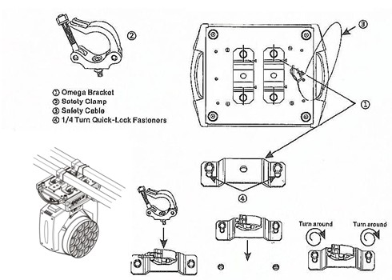

Regardless of the rigging option you choose for your 19pcs zoom, always be sure to secure your fixture with a safety cable. The fixture
provides a built -in rigging point for a safety cable on the hanging bracket as illustrated above. Be sure to only use the designated rigging point for the safety cable and never secure a safety cable to a carrying handle.

6. DMX-512 control connections
Connect the provided XLR cable to the female 3-pin XLR output of
your controller and the other side to the male 3-pin XLR input of the moving head. You can chain multiple.
Moving heads be connected together through serial linking. The cable
needed should be two core, screened cable with XLR input and output connectors. Please refer to the diagram below.

DMX-512 connection with DMX terminator

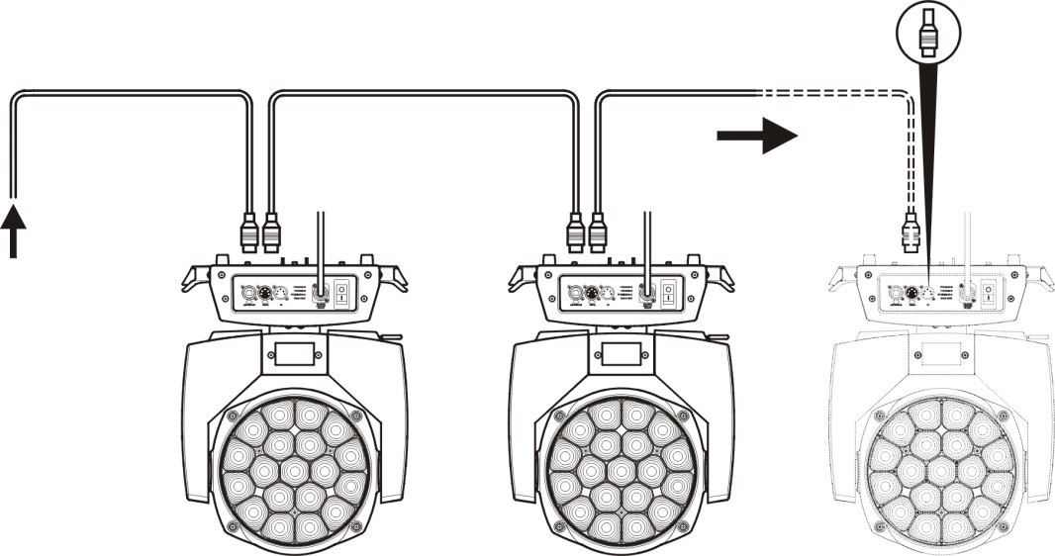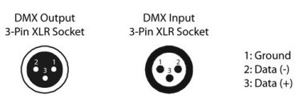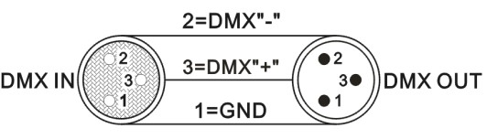

For installations where the DMX cable has to run a long distance or is in an electrically noisy environment, such as in a discotheque, it is recommended to use a DMX terminator. This helps in preventing corruption of the digital control signal by electrical noise. The DMX terminator is simply an XLR plug with a 120 Ω resistor connected between pins 2 and 3,which is then plugged into the output XLR socket of the last fixture in the chain. Please see illustrations below.
120Ω
1
2
3

_{PIN 3}
_{PIN 2}

7. DMX Channels

21 CH
CH | Function | DMX Value | Details
1 | Red | 0-255 | Red dimmer
2 | Red Fine | 0-255 | Red fine control
3 | Green | 0-255 | Green dimmer
4 | Green Fine | 0-255 | Green fine control
5 | Blue | 0-255 | Blue dimmer
6 | Blue Fine | 0-255 | Blue fine control
7 | White | 0-255 | White dimmer
8 | White Fine | 0-255 | White fine control
9 | CTO | 0-255 | Color temperature linear control
10 | Macro color | 0-255 | Marco color control
11 | strobe | 0-3 | Light up
11 | strobe | 4-203 | Strobe with the same step from slow to fast
11 | strobe | 204-255 | Random strobe
12 | Dimmer | 0-255 | 0-100 linear dimmer from dark to bright
13 | Dimmer Fine | 0-255 | Dimmer fine control
14 | Pan | 0-255 | Pan movement control
15 | Pan Fine | 0-255 | Pan fine control
16 | Tilt | 0-255 | Tilt movement control
17 | Tilt Fine | 0-255 | Pan fine control
18 | Function | 0-255
19 | Reset | 0-250 | No function
19 | Reset | 251-255 | Reset with 5 seconds
20 | Zoom | 0-255
21 | Zoom  Rotation | 0-127 | 0 to 60 degree
21 | Zoom  Rotation | 128-191 | Unlimited clockwise rotation from fast to slow
21 | Zoom  Rotation | 192-255 | Unlimited anticlockwise rotation from fast to slow

23 CH
CH | Function | DMX Value | Details
1 | Pan | 0-255 | Pan movement control
2 | Pan Fine | 0-255 | Pan fine control l
3 | Tilt | 0-255 | Tilt movement control
4 | Tilt fine | 0-255 | Pan fine control
5 | Pan/Tilt speed | 0-255 | Speed from fast to slow
6 | ZOOM | 0-255 | Zoom
7 | LENS rotation | 0-127 | White dimmer
7 | LENS rotation | 128-191 | Unlimited clockwise rotation from fast to slow
7 | LENS rotation | 192-255 | Unlimited anticlockwise rotation from fast to slow
8 | Dimmer | 0-255 | 0-100 linear dimmer from dark to bright
9 | Strobe | 0-3 | Light up
9 | Strobe | 4-203 | Strobe with the same step from slow to fast
9 | Strobe | 204-255 | Random strobe
10 | R | 0-255 | 1-100% Red linear dimmer from dark to bright
11 | G | 0-255 | 1-100% Green linear dimmer from dark to bright
12 | B | 0-255 | 1-100% Blue linear dimmer from dark to bright
13 | W | 0-255 | 1-100% White linear dimmer from dark to bright
14 | Color | 0-255 | Linear color temperature control
15 | Temperature | 0-255 | Marco color change
16 | Static effect | 0-255 | Each 5 DMX value is a kind of static effect
17 | Dynamic effect | 0-255 | Each 5 DMX value is a kind of dynamic effect
18 | Dynamic effect | 0-255 | Speed from slow to fast,pls operate against 15 CH
19 | Background R | 0-250 | 1-100% Background Red linear dimmer from dark to bright
20 | Background G | 0-255 | 1-100% Background Blue linear dimmer from dark to bright
21 | Background B | 0-255 | 1-100% Background Green linear dimmer from dark to bright
22 | Background W | 0-255 | 1-100% Background Blue linear dimmer from dark to bright
23 | Reset | 0-250 | No function
23 | Reset | 251-255 | Reset with 5 seconds

35 CH
CH | Function | DMX Value | Details
1 | Red | 0-255 | Red dimmer
2 | Red Fine | 0-255 | Red fine control
3 | Green | 0-255 | Green dimmer
4 | Green Fine | 0-255 | Green fine control
5 | Blue | 0-255 | Blue dimmer
6 | Blue Fine | 0-255 | Blue fine control
7 | White | 0-255 | White dimmer
8 | White Fine | 0-255 | White fine control
9 | CTO | 0-255 | Color temperature linear control
10 | Macro colour | 0-255 | Marco color control
11 | strobe | 0-3 | Light up
11 | strobe | 4-203 | Strobe with the same step from slow to fast
11 | strobe | 204-255 | Random strobe
12 | Dimmer | 0-255 | 0-100 linear dimmer from dark to bright
13 | Dimmer Fine | 0-255 | Dimmer fine control
14 | Pan | 0-255 | Pan movement control
15 | Pan Fine | 0-255 | Pan fine control
16 | Tilt | 0-255 | Tilt movement control
17 | Tilt Fine | 0-255 | Pan fine control
18 | Function | 0-255
19 | Reset | 0-250 | No function
19 | Reset | 251-255 | Reset with 5 seconds
20 | Zoom | 0-255
21 | Zoom Rotation | 0-127 | 0 to 60 degree
21 | Zoom Rotation | 128-191 | Unlimited clockwise rotation from fast to slow
21 | Zoom Rotation | 192-255 | Unlimited anticlockwise rotation from fast to slow
22 | Shape Selection | 0-255 | Selecting shape
23 | Shape Speed | 0-255 | Shape speed control
24 | Shape Fade | 0-255 | Shape fade
25 | Shape R | 0-255 | Shape in Red color
26 | Shape G | 0-255 | Shape in Green color
27 | Shape B | 0-255 | Shape in Blue color
28 | Shape W | 0-255 | Shape in White color
29 | Shape Dimmer | 0-255 | Shape dimmer 0-100%
30 | Background | 0-255 | Background dimmer 0-100%
31 | Shape Transition Dimmer | 0-255 | Shape change
32 | Shape Offset | 0-255 | Shape offset
33 | Foreground strobe | 0-255 | Foreground strobe control
34 | Background strobe | 0-255 | Background strobe control
35 | Background selection | 0-255 | Background selection

78 CH
CH | Function | DMX Value | Details
1 | Red | 0-255 | Red dimmer
2 | Red Fine | 0-255 | Red fine control
3 | Green | 0-255 | Green dimmer
4 | Green Fine | 0-255 | Green fine control
5 | Blue | 0-255 | Blue dimmer
6 | Blue Fine | 0-255 | Blue fine control
7 | White | 0-255 | White dimmer
8 | White Fine | 0-255 | White fine control
9 | CTO | 0-255 | Color temperature linear control
10 | Macro colour | 0-255 | Marco color control
11 | strobe | 0-3 | Light up
11 | strobe | 4-203 | Strobe with the same step from slow to fast
11 | strobe | 204-255 | Random strobe
12 | Dimmer | 0-255 | 0-100 linear dimmer from dark to bright
13 | Dimmer Fine | 0-255 | Dimmer fine control
14 | Pan | 0-255 | Pan movement control
15 | Pan Fine | 0-255 | Pan fine control
16 | Tilt | 0-255 | Tilt movement control
17 | Tilt Fine | 0-255 | Pan fine control
18 | Function | 0-255
19 | Reset | 0-250 | No function
19 | Reset | 251-255 | Reset with 5 seconds
20 | Zoom | 0-255
21 | Zoom Rotation | 0-127 | 0 to 60 degree
21 | Zoom Rotation | 128-191 | Unlimited clockwise rotation from fast to slow
21 | Zoom Rotation | 192-255 | Unlimited anticlockwise rotation from fast to slow
22 | Red dimmer 1 | 0-255 | LED 1 red dimmer
23 | Green dimmer 1 | 0-255 | LED 1 green dimmer
24 | Blue dimmer 1 | 0-255 | LED 1 blue dimmer
25 | Red dimmer 2 | 0-255 | LED 2 red dimmer
26 | Green dimmer 2 | 0-255 | LED 2 green dimmer
27 | Blue dimmer 2 | 0-255 | LED 2 blue dimmer
… | ……… | ……… | ………
… | ……… | ……… | ………
76 | Red dimmer 19 | 0-255 | LED 19 red dimmer
77 | Green dimmer19 | 0-255 | LED 19 green dimmer
78 | Blue dimmer 19 | 0-255 | LED 19 blue dimmer

92 CH
CH | Function | DMX Value | Details
1 | Red | 0-255 | Red dimmer
2 | Red Fine | 0-255 | Red fine control
3 | Green | 0-255 | Green dimmer
4 | Green Fine | 0-255 | Green fine control
5 | Blue | 0-255 | Blue dimmer
6 | Blue Fine | 0-255 | Blue fine control
7 | White | 0-255 | White dimmer
8 | White Fine | 0-255 | White fine control
9 | CTO | 0-255 | Color temperature linear control
10 | Macro colour | 0-255 | Marco color control
11 | strobe | 0-3 | Light up
11 | strobe | 4-203 | Strobe with the same step from slow to fast
11 | strobe | 204-255 | Random strobe
12 | Dimmer | 0-255 | 0-100 linear dimmer from dark to bright
13 | Dimmer Fine | 0-255 | Dimmer fine control
14 | Pan | 0-255 | Pan movement control
15 | Pan Fine | 0-255 | Pan fine control
16 | Tilt | 0-255 | Tilt movement control
17 | Tilt Fine | 0-255 | Pan fine control
18 | Function | 0-255
19 | Reset | 0-250 | No function
19 | Reset | 251-255 | Reset with 5 seconds
20 | Zoom | 0-255
21 | Zoom Rotation | 0-127 | 0 to 60 degree
21 | Zoom Rotation | 128-191 | Unlimited clockwise rotation from fast to slow
21 | Zoom Rotation | 192-255 | Unlimited anticlockwise rotation from fast to slow
22 | Shape Selection | 0-255 | Selecting shape
23 | Shape Speed | 0-255 | Shape speed control
24 | Shape Fade | 0-255 | Shape fade
25 | Shape R | 0-255 | Shape in Red color
26 | Shape G | 0-255 | Shape in Green color
27 | Shape B | 0-255 | Shape in Blue color
28 | Shape W | 0-255 | Shape in White color
29 | Shape Dimmer | 0-255 | Shape dimmer 0-100%
30 | Background Dimmer | 0-255 | Background dimmer 0-100%
31 | Shape Transition | 0-255 | Shape change
32 | Shape Offset | 0-255 | Shape offset
33 | Foreground strobe | 0-255 | Foreground strobe control
34 | Background strobe | 0-255 | Background strobe control
35 | Background select | 0-255 | Background selection
36 | Red dimmer 1 | 0-255 | LED 1 red dimmer
37 | Green dimmer 1 | 0-255 | LED 1 green dimmer
38 | Blue dimmer 1 | 0-255 | LED 1 blue dimmer
39 | Red dimmer 2 | 0-255 | LED 2 red dimmer
40 | Green dimmer 2 | 0-255 | LED 2 green dimmer
41 | Blue dimmer 2 | 0-255 | LED 2 blue dimmer
… | ……… | ……… | ………
… | ……… | ……… | ………
90 | Red dimmer 19 | 0-255 | LED 19 red dimmer
91 | Green dimmer 19 | 0-255 | LED 19 green dimmer
92 | Blue dimmer 19 | 0-255 | LED 19 blue dimmer

97 CH
CH | Function | DMX Value | Details
1 | Red | 0-255 | Red dimmer
2 | Red Fine | 0-255 | Red fine control
3 | Green | 0-255 | Green dimmer
4 | Green Fine | 0-255 | Green fine control
5 | Blue | 0-255 | Blue dimmer
6 | Blue Fine | 0-255 | Blue fine control
7 | White | 0-255 | White dimmer
8 | White Fine | 0-255 | White fine control
9 | CTO | 0-255 | Color temperature linear control
10 | Macro colour | 0-255 | Marco color control
11 | strobe | 0-3 | Light up
11 | strobe | 4-203 | Strobe with the same step from slow to fast
11 | strobe | 204-255 | Randon strobe
12 | Dimmer | 0-255 | 0-100 linear dimmer from dark to bright
13 | Dimmer Fine | 0-255 | Dimmer fine control
14 | Pan | 0-255 | Pan movement control
15 | Pan Fine | 0-255 | Pan fine control
16 | Tilt | 0-255 | Tilt movement control
17 | Tilt Fine | 0-255 | Pan fine control
18 | Function | 0-255
19 | Reset | 0-250 | No function
19 | Reset | 251-255 | Reset with 5 seconds
20 | Zoom | 0-255
21 | Zoom Rotation | 0-127 | 0 to 60 degree
21 | Zoom Rotation | 128-191 | Unlimited clockwise rotation from fast to slow
21 | Zoom Rotation | 192-255 | Unlimited anticlockwise rotation from fast to slow
22 | Red dimmer 1 | 0-255 | LED 1 red dimmer
23 | Green dimmer 1 | 0-255 | LED 1 green dimmer
24 | Blue dimmer 1 | 0-255 | LED 1 blue dimmer
25 | White dimmer 1 | 0-255 | LED 1 white dimmer
… | ……… | ……… | ………
… | ……… | ……… | ………
94 | Red dimmer 19 | 0-255 | LED 19 red dimmer
95 | Green dimmer 19 | 0-255 | LED 19 green dimmer
96 | Blue dimmer 19 | 0-255 | LED 19 blue dimmer
97 | White dimmer 19 | 0-255 | LED 19 white dimmer

8.Board connection:
Main board:
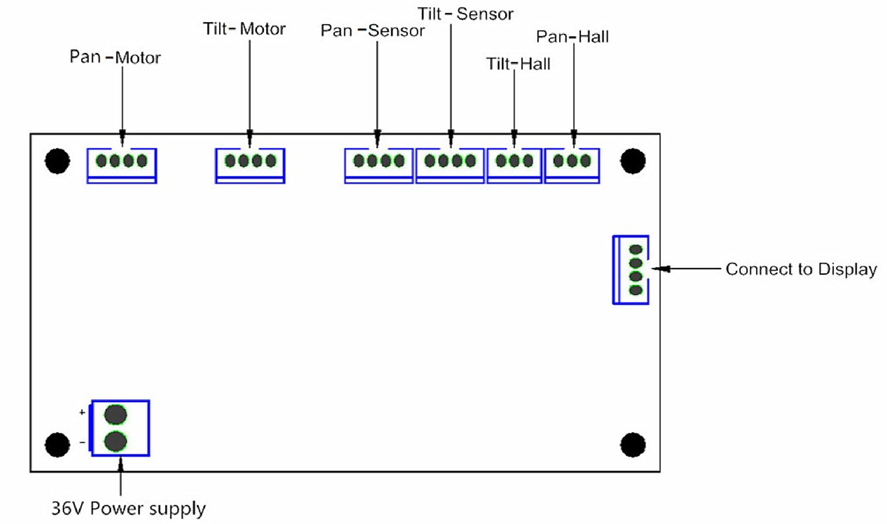

Screen board:
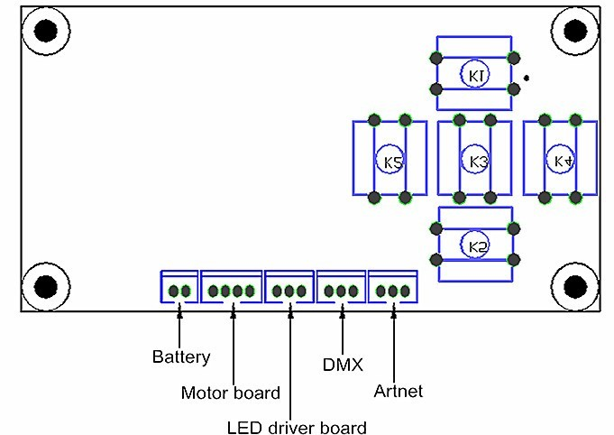

9. Tecnical Specifications
Voltage: AC100V ～240V 50-60HZ
Power: 450W
LED Source: 19x15W high power RGBW 4 in 1 LEDs
Led drive current: 1000mA
Zoom angle: 8-45°
Strobe: 0-20Hz
DMX Channels: 21 CH/23 CH/35 CH/78 CH/92 CH/97 CH
Motor: 3-phased (mute sound motor)
Control mode: DMX512, Sound Control, Auto running, Master/slave
Dimmer: 0-100% linear dimmer
Pan: 540°+16bit fine
Tilt: 270°+16bit fine
Effects: CTO, Wash, Beam , Zoom, RGBW Full Colors Control, Effect Mode(windmill, kaleidoscope), Lens Plate Variable Direction Infinite Rotation
Display: LCD colorful display
IP: IP20
Carton package size: 49*36*47CM (1pcs/ctn)
W:16 Kg
G.W: 17Kg

Special Points.
Each LED can be controlled individually. With unique honeycomb designed lens
The front lens can rotate without limitation in forward and reverse direction to create amazing effects
Display screen can be turned upside down with 180°automatically to fit the installation in different place, Display can be equipped with rechargeable battery to set DMX address without power connection.
Can be used as beam, wash or effect light use (Kaleido effects )
The scanning position can be memory, it will be automatically reset without expected movement after rotation.

Fan cooling (fan will be change the speed with the temperature variation ).
Temperature detecting system (If the temperature detected error, the light will stop working to protect the fixture)

10. Photometric Data:
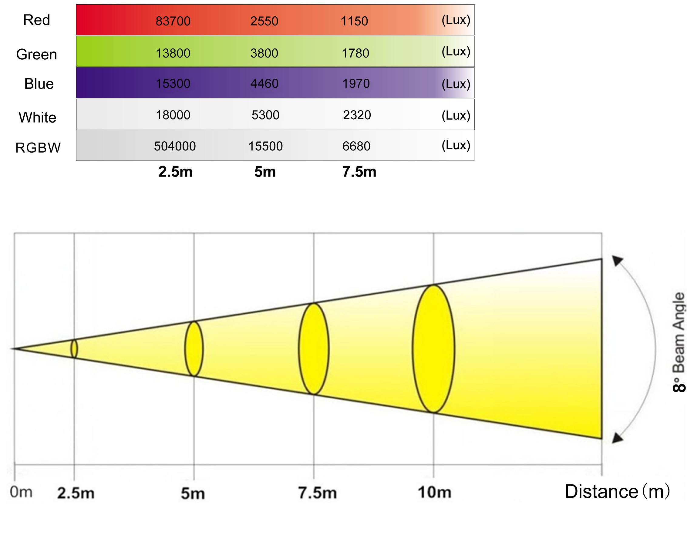

11. Maintenance and Cleaning
The following points have to be considered during the inspection:

- All screws for installing the devices or parts of the device have to be tightly connected and must not be corroded.
- There must not be any deformations on the housing, color lenses, fixations and installation spots (ceiling, suspension, trussing).
- Mechanically moved parts must not show any traces of wearing and must not rotate with unbalances.
4. The electric power supply cables must not show any damage, material fatigue or sediments.
Further instructions depending on the installation spot and usage have to be adhered by a skilled installer and any safety problems have to be removed.

In order to make the lights in good condition and extend the life time, we suggest a regular cleaning to the lights.
- Clean the inside and outside lens each week to avoid the weakneness of the lights due to accumulation of dust.

- Clean the fan each week.

- A detailed electric check by approved electrical engineer each three
month, make sure that the circuit contacts are in good condition, prevent the poor contact of circuit from overheating.
We recommend a frequent cleaning of the device. Please use a moist, lint - free cloth. Never use alcohol or solvents.There are no serviceable parts inside the device. Please refer to the instructions under “Installation instructions”.Should you need any spare parts, please order genuine parts from your local dealer.

